**CLARKSON SURGERY NEWSLETTER**

**JULY 2024**

Dear Patient

We wanted to update all our patients with what has been happening at your surgery.

**Message from our Practice Manager (Terri Zeferino)**

I’m delighted to have joined Clarkson Surgery and look forward to supporting our hard working, committed team in providing high quality services to you all when you need them.

We aim to ensure our patient ‘experience’ is as positive as possible

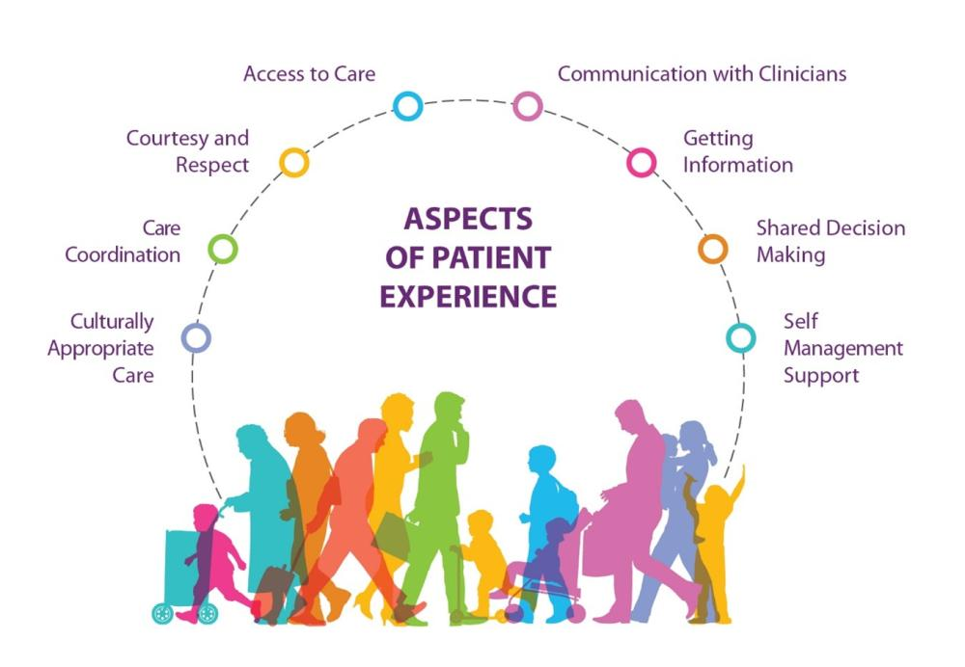

and we encourage you to complete feedback forms regularly so we can keep an eye on how we are doing and ask you that if things do go wrong, to raise them with us so they can be reviewed and sorted out quickly. **We are here to help**.

We are keen to engage our patients in developing our services further and welcome your interest in joining our Patient Participation Group (PPG) – the first meeting with our new and existing team of volunteers is being held at 18.30 on Monday 19th August in the Practice. Please contact our Reception team if you wish to attend or apply to join us ☺.

**During April to June Clarkson Surgery Provided:**

17,464 Appointments

10,538 Were Face to Face Appointments

4,498 Were Face to Face Appointments with a GP

625 Telephone Consultations

7,879 On the Day Appointments

625 Appointments Where the Patient Did Not Attend ☹

**(Please ensure you inform us if you are unable to attend so the appointment can be offered to someone else)**

581 Long Term Condition Annual Reviews

89 Home Visits

1963 Phlebotomy Appointments

1781 Blood Pressures Taken

PLUS lots of other appointments: Dressings, Vaccinations, Smears, and Health Checks etc.

Primary Care has changed over recent years and we now have a multi-disciplinary team to support all our patients’ needs. They include a mix of health and care professionals who work together to meet the social, physical and mental wellbeing needs of our local population whilst providing care closer to people’s homes.

This means you will be directed to the most appropriate colleague based on your medical condition needs and this may not be a GP.

By working in this manner, it enables us to provide far more patient contacts than we were able to provide previously.

**Our Patient Journey**

When you call the surgery, you will speak to a colleague from our reception team who will ask you for some details about your medical problem.

These details are shared with a clinical member of staff who triage to ensure you are directed to the most appropriate person or service to handle your problem. Sometimes the triaging clinician may ask for more details at this point.

The clinicians or services you may be referred to include:

* Doctor
* Advanced Nurse Practitioner (ANP)
* Paramedic
* Practice Nurse
* Health Care Assistant (HCA)
* Pharmacist
* Diabetic nurse
* Mental Health nurse
* First Contact Physiotherapist
* Stop smoking service
* To our website to request sick notes for ongoing issues
* Minor Injury Unit (MIU) at North Cambridgeshire Hospital Wisbech who provide care and treatment for patients whose injuries or illnesses are not severe enough to require A&E and offer an access, examination, diagnosis and treatment plan for injuries, including wound closures, plaster casts and splints and x-ray services if required.
* Community Pharmacy First who can provide medications for sinusitis, sore throat, earache, infected bites and stings, impetigo, uncomplicated UTI’s in women.
* Self-care
* Hospital (A&E)
* NHS 111

**Appointment bookings**

If you need an appointment **on the day** for a new or ongoing health problem, then please telephone us from 8.30 am Monday to Friday until our acute appointment capacity is full. You will be triaged and placed with the most appropriate colleague as quickly as possible who will call you and determine the right treatment plan for you. Additionally, we provide:

* **Pre-bookable appointments during our core hours of 8.30am – 6.30pm** – these are utilised by our clinicians for patients who need to be followed up following test results and ongoing care. Other pre-bookable appointments are available to cover specific health related clinics e.g. child immunisations, cervical screening and long term health condition reviews.
* **Pre-bookable appointments outside our core hours 6.30 – 8.00 pm Mon-Fri, 9.00 am to 5.00pm Saturdays** – available for all patients registered at any of the 4 Wisbech GP surgeries, specifically for those patients who struggle to be seen/spoken to during our core opening hours – these are booked by contacting us directly.
* **Home visit requests** – generally for housebound patients or if you are too ill to come to the surgery. Where possible please call us between 8.30am to 10.00am to request. We are unable to provide home visits if you do not have transport to get to the surgery.

**Contacting our Surgery**

We have recently upgraded our telephone system following patient feedback and this is working well with many patients advising how much easier it now is to get through to us. We have also increased our Clinical Triage team. A new feature ‘Callback’ has also been activated which enables you to keep your place in the queue but without the need to physically hold on the line – we will call you back when your place is reached.

**Long Acting Reversible Contraception (LARC)**

We have started these clinics which include a COIL and Implant fitting and removal service. Please call reception to make an appointment (01945 583133).

**COVID Vaccinations**

We are not offering the Autumn COVID vaccinations due to contract issues. Those patients who are eligible will be able to obtain their vaccination from local hubs. We will be displaying information regarding these clinics/drop in sessions on our website, Facebook page and notice boards in the surgery when they become available to us.

**Flu Vaccinations**

Following the surgery securing our flu vaccinations, we are in the final process of setting up clinics for this year’s flu vaccinations for October 2024. If you are eligible for this year’s FREE flu vaccination, you will receive a text message with a booking link on when our appointments are live. Please also keep an eye out on our website, Facebook page and notice boards in the surgery with more information.

**Dispensary**

Our dispensary offers a first class service to our patients including a Managed Repeat Prescription service for our Dispensing patients, which eliminates the need to remember to order your repeat prescription each month, please contact the dispensary on 01945 583 133 opt 4 to sign up for this. We also have our free of charge delivery service for our dispensing patients, delivering to approx. 450 patients.

**Hepatitis C Screening**

We are continuing to work with Addenbrookes Hospital to identify our at risk patients for the Hepatitis C virus. We will be offering screening and follow up treatment. All at risk patients will be contacted and invited to this service. If you think you may be at risk there is the alternative on ordering a kit on line at <https://hepctest.nhs.uk/>

**Facebook and Website**

We have an active Facebook page which is regularly updated with surgery news health information and promotion, please follow us to keep up to date [www.facebook.com/clarksonsurgery](http://www.facebook.com/clarksonsurgery)

Check our website to register with the surgery, health information, ordering medication, contact us on line at [www.clarksonsurgery.co.uk](http://www.clarksonsurgery.co.uk)

**Training Days**

To ensure our Practice teams are kept up-to-date with what’s going on including new developments and specific training and to assist them feeling involved in our surgery we hold a training afternoon each month where the Practice is closed to patients from 1pm until the next working day.

Our next Staff Training dates are:

Wednesday 17th July

Thursday 19th September

Tuesday 22nd October

Wednesday 20th November

During these times, if you require assistance and cannot defer your query until the next day, the following services are available to you:

* **Call** 111 if you need medical help or advice fast – **but it’s** **not an emergency**. The 111 online service can also help if you're not sure what to do for your symptoms.
* **Call 999** if someone is **seriously ill or injured and their life is at risk**.
* Go to the local **Minor Injuries Unit (North Cambs Hospital)** if you have a minor illness or injury (cuts, sprains, rashes).
* Your **local pharmacy** can give you advice about many common minor illnesses such as diarrhoea, headaches and sore throats.

